Class P and NP

In computer science, there exist several famous unresolved problems, and P=NP is one of the most studied ones. Until now, the answer to that problem is mainly “no”. And, this is accepted by the majority of the academic world. We probably wonder why this problem is still not resolved.

Classification
- To explain P, NP and others, let’s use the same mindset that we use to classify problems in real life. While we could use a wide range of terms to classify problems, in most cases we use an “Easy-to-Hard” scale.
- Now, in theoretical computer science, the classification and complexity of common problem definitions have two major sets; P which is “Polynomial” time and NP which “Non-deterministic Polynomial” time. There are also NP-Hard and NP-Complete sets, which we use to express more sophisticated problems. In the case of rating from easy to hard, we might label these as “easy”, “medium”, “hard”, and finally “hardest”:

Decision Problem
Decision problems have yes or no answers.
Mathematicians like to simplify analysis, so they consider only decision problems. Nevertheless many problems can be reduced to a decision problem.
All existence problems are decision problems, for example does the graph has a
cycle is a decision problem.
Many construction problems are related to decision problems by asking if a potential solution of the problem is in fact a solution. The potential solution to the problem is part of the input to the problem.
If that if there are only polynomial solutions and each solution can be generated in polynomial time then the related decision problem can solve the construction problem in polynomial time by generating and checking each potential solution.

Definition of Class P Problem
Class P is a class of all decision problems that can be solved in polynomial time by deterministic algorithms.
Deterministic algorithms are the algorithms that do not guess at a solution.

Definition of Nondeterministic Algorithm
An informal definition for a nondeterministic algorithm is an algorithm that can guess at the solution (nondeterministic step) but checks that the solution is correct using a deterministic algorithm.

Definition of Class NP Problems
Class NP is the class of all decision problems that a nondeterministic algorithm can solve in polynomial time.

Note P is a subset of NP

We do not know if P is equal to NP.

NP-Complete Problems
The informal definition of NP-complete (NPC) problem is NP problem that is as difficult as any other problem in NP.

Definition of Polynomially Reducible
A decision problem D1 is polynomially reducible to another decision problem D2 if there exist a function t that transform instances of D1 to instances of D2 such that
- t maps all yes/no instances of D1 to yes/no instances of D2
- t is polynomial time

Definition of NPC Problems
A decision problem, D, is NP complete if
- It belongs to NP
- Every problem in NP is polynomial reducible to D

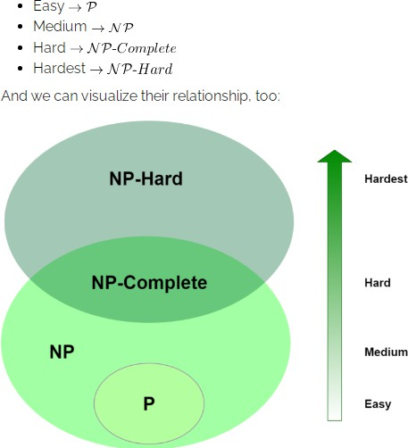

Using the diagram, we assume that P and NP are not the same set, or, in other words, we assume that P!=NP. This is our apparently-true, but yet-unproven assertion. Of course, another interesting aspect of this diagram is that we’ve got some overlap between NP and NP-Hard. We call NP-Complete when the problem belongs to both of these sets

Some common Big-O values
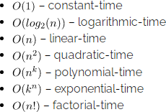
where k is a constant and n is the input size. The
size of n also depends on the problem definition. For example, using a number set with a size of n,
the search problem has an average complexity
between
linear-time
and
logarithmic-time
depending on the data structure in use.

Polynomial Algorithms
The first set of problems are polynomial algorithms that we can solve in polynomial time, like logarithmic, linear or quadratic time. If an algorithm is polynomial, we can formally define its time complexity as:
In general, for polynomial-time algorithms k is expected to be less than n. Many algorithms complete in polynomial time:
- All basic mathematical operations; addition, subtraction, division, multiplication
- Testing for primacy
- Hashtable lookup, string operations, sorting problems
- Shortest Path Algorithms; Djikstra, Bellman-Ford, Floyd-Warshall
- Linear and Binary Search Algorithms for a given set of numbers

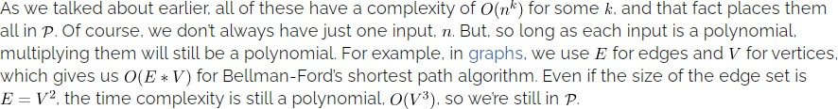

NP Algorithms
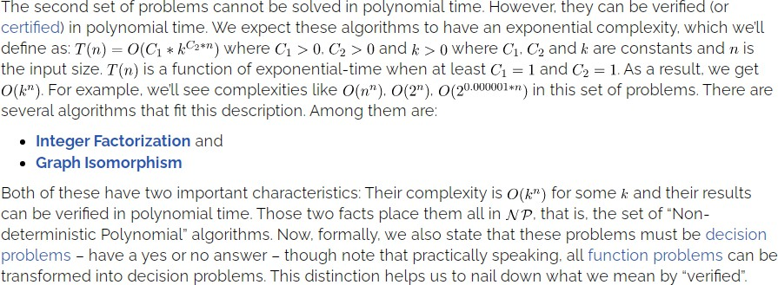

To speak precisely, then, an algorithm is in NP if it can’t be solved in
polynomial time and the set of solutions to any decision problem can be verified in polynomial time by a “Deterministic Turing Machine“. What makes Integer Factorization and Graph Isomorphism interesting is that while we believe they are in NP, there’s no proof of whether they are in P and NP-Complete.

NP-Complete Algorithms
For any NP problem that’s complete, there exists a polynomial-time algorithm that can transform the problem into any other NP-complete problem. This transformation requirement is also called reduction.
There are numerous NP problems proven to be complete. Among them are:
Traveling Salesman
Knapsack, and
Graph Coloring
Curiously, what they have in common, aside from being in NP, is that each can be
reduced into the other in polynomial time. These facts together place them in NP-Complete.

NP-Hard Algorithms
Our last set of problems contains the hardest, most complex problems in computer science. They are not only hard to solve but are hard to verify as well. In fact, some of these problems aren’t even decidable. Among the hardest computer science problems are:
K-means Clustering
Traveling Salesman Problem, and
Graph Coloring
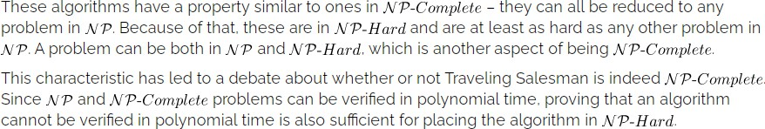

So, Does P=NP?
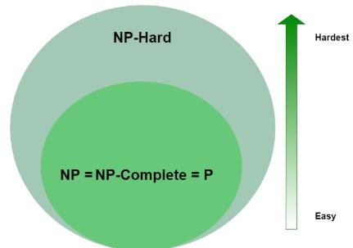

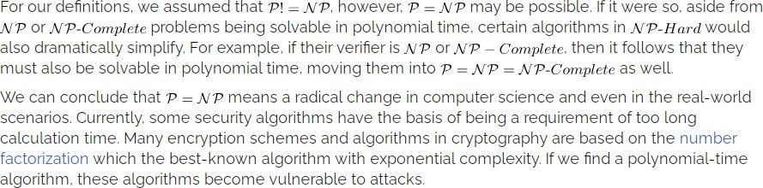


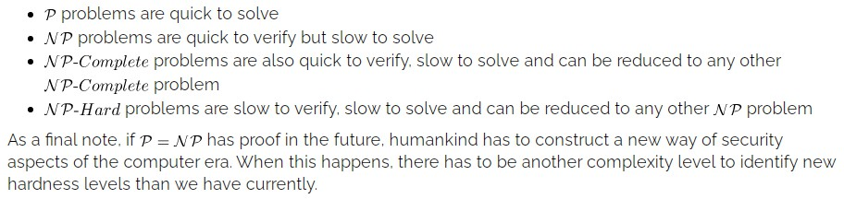
Summary

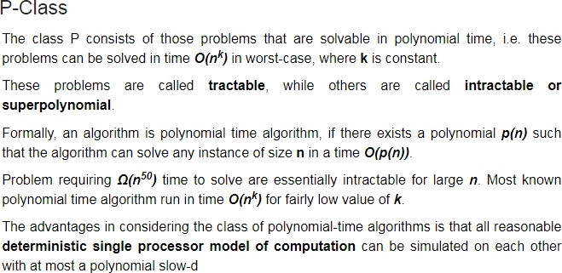

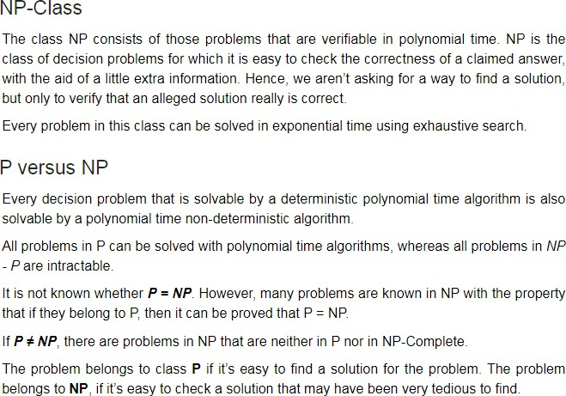

Reductions
Concept: - If the solution of NPC problem does not exist then the conversion from one NPC problem to another NPC problem within the polynomial time. For this, you need the concept of reduction. If a solution of the one NPC problem exists within the polynomial time, then the rest of the problem can also give the solution in polynomial time (but it's hard to believe). For this, you need the concept of reduction.
Example: - Suppose there are two problems, A and B. You know that it is impossible to solve problem A in polynomial time. You want to prove that B cannot be solved in polynomial time. So you can convert
the problem A into problem B in polynomial time.

NP-hard | NP-Complete
NP-Hard problems(say X) can be solved if and only if there is a NP-Complete problem(say Y) that can be reducible into X in polynomial time. | NP-Complete problems can be solved by a non-deterministic Algorithm/Turing Machine in polynomial time.
To solve this problem, it do not have  to be in NP . | To solve this problem, it must be  both NP and NP-hard problems.
Do not have to be a Decision problem. | It is exclusively a Decision problem.
Example: Halting problem, Vertex  cover problem, etc. | Example: Determine whether a graph has a Hamiltonian cycle, Determine whether a Boolean formula is satisfiable or not, Circuit-satisfiability problem, etc.

Polynomial-time reduction

In computational complexity theory, a polynomial-time reduction is a
method for solving one problem using another. One shows that if a hypothetical subroutine solving the second problem exists, then the first problem can be solved by transforming or reducing it to inputs for the second problem and calling the subroutine one or more times. If both the time required to transform the first problem to the second, and the number of times the subroutine is called is polynomial, then the first problem is polynomial-time reducible to the second

A polynomial-time reduction proves that the first problem is no more difficult than the second one, because whenever an efficient algorithm exists for the second problem, one exists for the first problem as well. By contraposition, if no efficient algorithm exists for the first problem, none
exists for the second either.

- Polynomial-time reductions are frequently used in complexity theory for
defining both complexity classes and complete problems for those classes.

- The three most common types of polynomial-time reduction, from the most to the least restrictive, are polynomial-time many-one reductions, truth-table reductions, and Turing reductions. The most frequently used of these are the many-one reductions, and in some cases the phrase "polynomial-time reduction" may be used to mean a polynomial-time many-one reduction.

- The most general reductions are the Turing reductions and the most restrictive are the many-one reductions with truth-table reductions occupying the space in between

Many-one reductions
A polynomial-time many-one reduction from a problem A to a problem B (both of which are usually required to be decision problems) is a polynomial-time algorithm for transforming inputs to problem A into inputs to problem B, such that the transformed problem has the same output as the original problem. An instance x of problem A can be solved by applying this transformation to produce an instance y of problem B, giving y as the input to an algorithm for problem B, and returning its output. Polynomial-time many-one reductions may also be known as polynomial transformations or Karp reductions, named after Richard Karp. A reduction of this type is denoted by

Truth-table reductions
A polynomial-time truth-table reduction from a problem A to a problem B (both decision problems) is a polynomial time algorithm for transforming inputs to problem A into a fixed number of inputs to problem B, such that the output for the original problem can be expressed as a function of the outputs for B. The function that maps outputs for B into the output for A must be the same for all inputs, so that it can be expressed by a truth table. A reduction of this type
may be denoted by the expression

Turing reductions
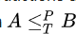
A polynomial-time Turing reduction from a problem A to a problem B is an algorithm that solves problem A using a polynomial number of calls to a subroutine for problem B, and polynomial time outside of those subroutine calls. Polynomial-time Turing reductions are also known as Cook reductions, named after Stephen Cook. A reduction of this type may be denoted by the expression

Many-one reductions can be regarded as restricted variants of Turing reductions where the number of calls made to the subroutine for problem B is exactly one and the value returned by the reduction is the same value as the one returned by
the subroutine.

A complete problem for a given complexity class C and reduction ≤ is
a problem P that belongs to C, such that every problem A in C has a reduction A ≤ P. For instance, a problem is NP-complete if it belongs to NP and all problems in NP have polynomial-time many-one reductions to it.

A problem that belongs to NP can be proven to be NP-complete by finding a single polynomial-time many-one reduction to it from a
known NP-complete problem

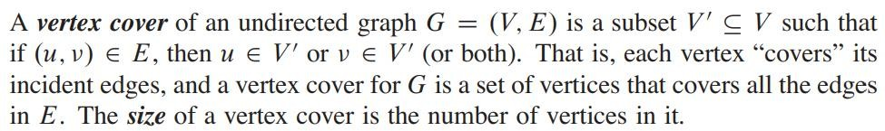
Vertex Cover Problem
For example, the graph has a vertex cover {w,z} of size 2.
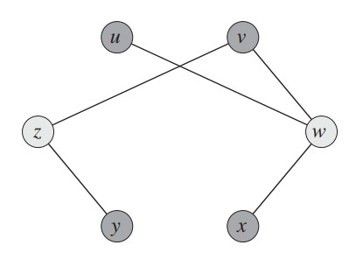
The vertex-cover problem is to find a vertex cover of minimum size in a given graph. Restating this optimization problem as a decision problem, we wish to determine whether a graph has a vertex cover of a given size k. As a language, we define

Approximate Algorithm for Vertex Cover:

- Initialize the result as {}
- Consider a set of all edges in given graph. Let the set be E.
- Do following while E is not empty
...a) Pick an arbitrary edge (u, v) from set E and add 'u' and 'v' to result
...b) Remove all edges from E which are either incident on u or v.
- Return result

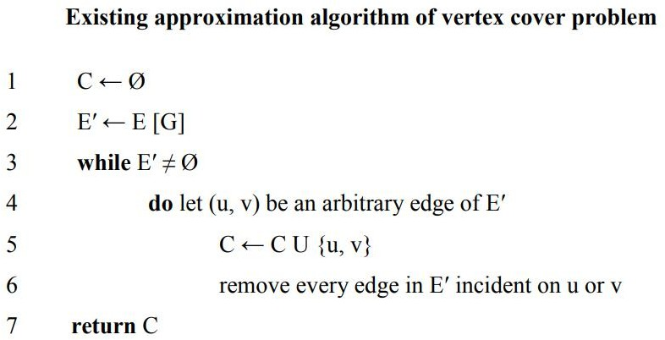

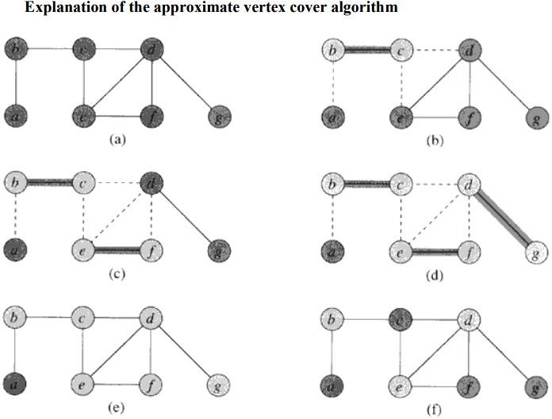

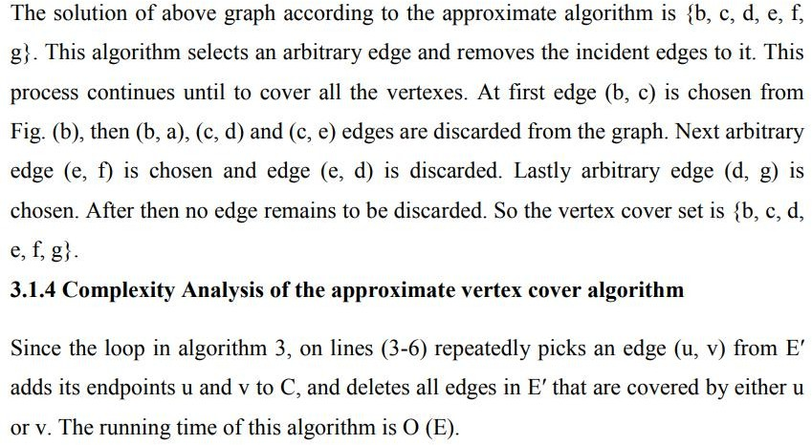

- In computer science, the vertex cover problem or node cover problem is one of Karp's 21 NP-complete problems. It is often used in complexity theory to prove NPhardness of more complicated problems.
- The size of a vertex cover is the number of vertices in it. The vertex cover problem is to find a vertex cover of minimum size in a given undirected graph. Such a vertex cover is called an optimal vertex cover.
- There are two versions of the minimum vertex cover problem: the decision version and the optimization one.
- In the decision version, the task is to verify for a given graph whether there exists a vertex cover of a specified size. On the other hand, in the optimization version of this problem, the task is to find a vertex cover of minimum size.

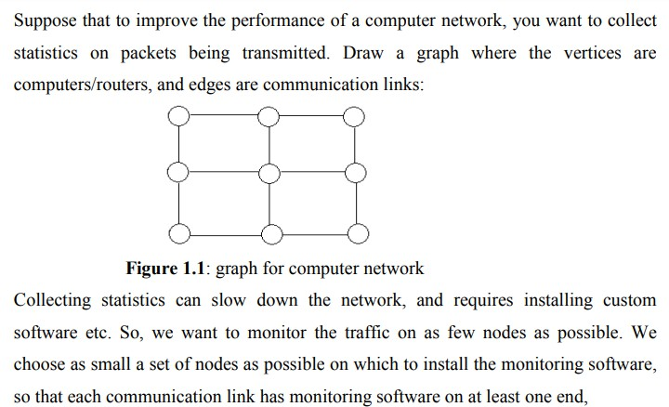

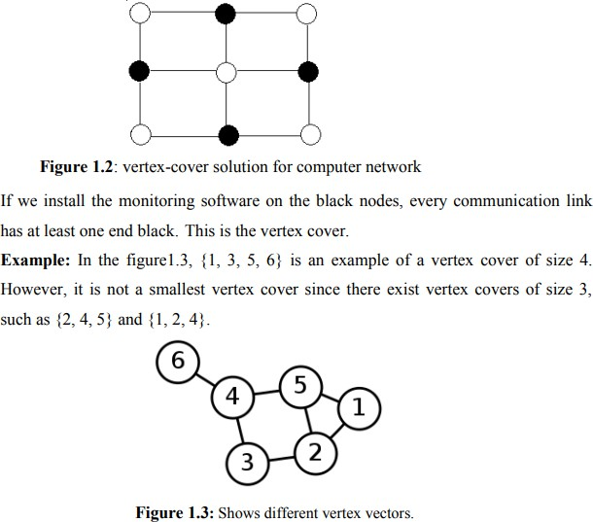

Clique Problem

- In an undirected graph, a clique is a complete sub-graph of the given graph. Complete sub-graph means, all the vertices of this sub-graph is connected to all other vertices of this sub-graph.

- The Max-Clique problem is the computational problem of finding maximum clique of the graph. Max clique is used in many real-world problems.

- The clique problem arises in the following real-world setting. Consider a social network, where the graph's vertices represent people, and the graph's edges represent mutual acquaintance. Then a clique represents a subset of people who all know each other, and algorithms for finding cliques can be used to discover these groups of mutual friends. Along with its applications in social networks, the clique problem also has many applications in bioinformatics,
and computational chemistry.

- Most versions of the clique problem are hard.
- The clique decision problem is NP-complete (one of Karp's 21 NP-complete problems).
- The problem of finding the maximum clique is both fixed-parameter intractable and hard to approximate. And, listing all maximal cliques may require exponential time as there exist graphs with exponentially many maximal cliques.

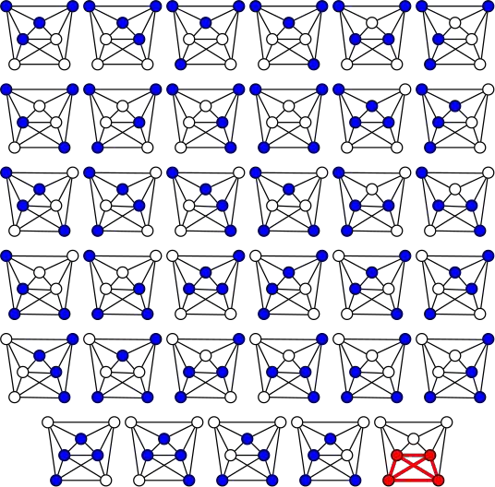
The brute force algorithm
finds a 4-clique in this 7-vertex graph (the complement of the
7-vertex
path
systematically
graph)
checking
by
all
C(7,4) = 35 4-vertex subgraphs
for completeness.

- To find a maximum clique, one can systematically inspect all subsets, but this sort of brute-force search is too time-consuming to be practical for networks comprising more than a few dozen vertices. Although no polynomial time algorithm is known for this problem, more efficient algorithms than the brute-force search are known.
- For instance, the Bron–Kerbosch algorithm can be used to list all maximal cliques in worst-case optimal time, and it is also possible to list them in polynomial time per clique
- A clique of size k in a graph G is a clique of graph G containing k vertices, i.e. the degree of each vertex is k-1 in that clique. So particularly, if there is a subset of k vertices that are connected to each other in the graph G, we say that graph contains a k-clique.
- A k-clique can be a maximal clique or can be a subset of a maximal clique, so if a graph contains a clique of size more than k then it definitely contains a clique of size k.
- For example the graph shown below:
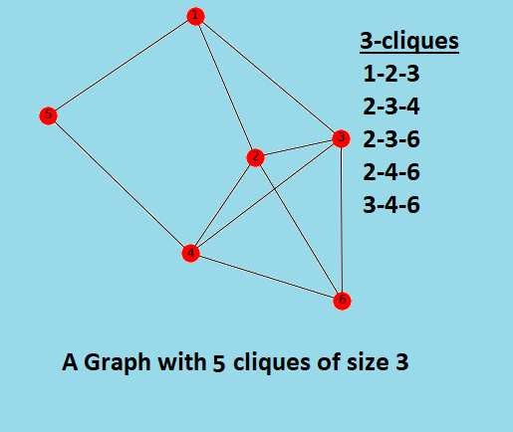

A clique is a subgraph of a graph such that all the vertices in this subgraph are connected with each other that is the subgraph is a complete graph. The Maximal Clique Problem is to find the maximum sized clique of a given graph G, that is a complete graph which is a subgraph of G and contains the maximum number of vertices. This is an optimization problem. Correspondingly, the Clique Decision Problem is to find if a clique of size k exists in the given graph or not
To prove that a problem is NP-Complete, we have to show that it belongs to both NP and NP-Hard Classes. (Since NP-Complete problems are NP-Hard problems which also belong to NP)

The Clique Decision Problem belongs to NP – If a problem belongs to the NP class, then it should have polynomial-time verifiability, that is given a certificate, we should be able to verify in polynomial time if it is a solution to the problem.

Proof:
Certificate – Let the certificate be a set S consisting of nodes in the clique and S is a subgraph of G.
Verification – We have to check if there exists a clique of size k in the graph. Hence, verifying if number of nodes in S equals k, takes O(1) time. Verifying whether each vertex has an out-degree of (k-1) takes O(k²) time. (Since in a complete graph, each vertex is connected to every other vertex through an edge. Hence the total number of edges in a complete graph = ^{k}C₂ = k*(k-1)/2 ). Therefore, to check if the graph formed by the k nodes in S is complete or not, it takes O(k²) = O(n²) time (since k<=n, where n is number of vertices in G).

Therefore, the Clique Decision Problem has polynomial time verifiability and hence belongs to the NP Class.

The Clique Decision Problem belongs to NP-Hard – A problem L belongs to NP-Hard if every NP problem is reducible to L in polynomial time. Now, let the Clique Decision Problem by C. To prove that C is NP-Hard, we take an already known NP-Hard problem, say S, and reduce it to C for a particular instance. If this reduction can be done in polynomial time, then C is also an NP-Hard problem. The Boolean Satisfiability Problem (S) is an NP-Complete problem as proved by the Cook’s theorem. Therefore, every problem in NP can be reduced to S in polynomial time. Thus, if S is reducible to C in polynomial time, every NP problem can be reduced to C in polynomial time, thereby proving C to be NP-Hard.

Proof that the Boolean Satisfiability problem reduces to the Clique Decision
Problem
Let the boolean expression be – F = (x1 v x2) ^ (x1‘ v x2‘) ^ (x1 v x3) where x1, x2, x₃ are the variables, ‘^’ denotes logical ‘and’, ‘v’ denotes logical ‘or’ and x’ denotes the complement of x. Let the expression within each parentheses be a clause. Hence we have three clauses – C1, C2 and C3. Consider the vertices as – <x1, 1>;
<x2, 1>; <x1’, 2>; <x2’, 2>; <x1, 3>; <x3, 3> where the second term in each vertex
denotes the clause number they belong to. We connect these vertices such that – No two vertices belonging to the same clause are connected.
No variable is connected to its complement.

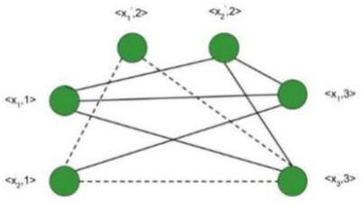
Thus, the graph G (V, E) is constructed such that – V = { <a, i> | a belongs to Ci } and E = { ( <a, i>,
<b, j> ) | i is not equal to j ; b is not equal to a’ } Consider the subgraph of G with the vertices
<x₂, 1>; <x₁’, 2>; <x₃, 3>. It forms a clique of size 3 (Depicted by dotted line in above figure) . Corresponding to this, for the assignment – <x₁, x₂, x₃> = <0, 1, 1> F evaluates to true. Therefore, if we have k clauses in our satisfiability expression, we get a max clique of size k and for the corresponding assignment of values, the satisfiability expression evaluates to true. Hence, for a particular instance, the satisfiability problem is reduced to the clique decision problem.
Therefore, the Clique Decision Problem is NP-Hard.
Conclusion
The Clique Decision Problem is NP and NP-Hard. Therefore, the Clique decision problem is NP-Complete.

Flow Networks and Network Flow

Flow Networks and Flows
Flow Network is a directed graph that is used for modeling material Flow. There are two different vertices; one is a source which produces material at some steady rate, and another one is sink which consumes the content at the same constant speed. The flow of the material at any mark in the system is the rate at which the element moves.

Some real-life problems like the flow of liquids through pipes, the current through wires and delivery of goods can be modeled using flow networks.

Definition: A Flow Network is a directed graph G = (V, E) such that

For each edge (u, v) ∈ E, we associate a nonnegative weight capacity c (u, v) ≥ 0.If (u, v) ∉ E, we assume that c (u, v) = 0.
There are two distinguishing points, the source s, and the sink t; For every vertex v ∈ V, there is a path from s to t containing v.

Let G = (V, E) be a flow network. Let s be the source of the network, and let t be the sink. A flow in G is a real-valued function f: V x V→R such that the following properties hold:
- Capacity Constraint: For all u, v ∈ V, we need f (u, v) ≤ c (u, v).
- Skew Symmetry: For all u, v ∈ V, we need f (u, v) = - f (u, v).
- Flow Conservation: For all u ∈ V-{s, t}, we need
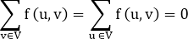

The quantity f (u, v), which can be positive or negative, is known as the net flow from vertex u to vertex v. In the maximum-flow problem, we are given a flow network G with source s and sink t, and we wish to find a flow of maximum value from s to t.
The three properties can be described as follows:
- Capacity Constraint makes sure that the flow through each edge is not greater than the capacity.
- Skew Symmetry means that the flow from u to v is the negative of the flow from v to u.
- The flow-conservation property says that the total net flow out of a vertex other than the source or sink is 0. In other words, the amount of flow into a v is the same as the amount of flow out of v for every vertex v ∈ V - {s, t}

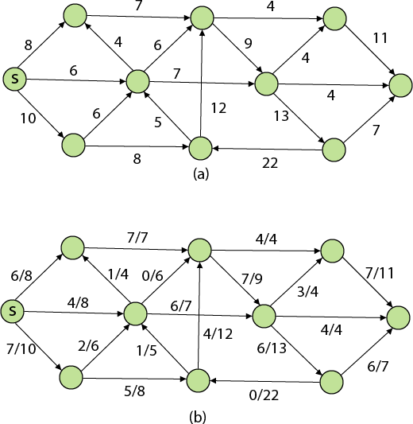

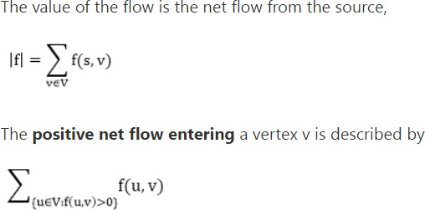

The positive net flow leaving a vertex is described symmetrically. One interpretation of the Flow-Conservation Property is that the positive net flow entering a vertex other than the source or sink must equal the positive net flow leaving the vertex.

A flow f is said to be integer-valued if f (u, v) is an integer for all (u, v) ∈ E. Clearly, the value of the flow is an integer is an integer-valued flow.

Network Flow Problems
The most obvious flow network problem is the following:
Problem1: Given a flow network G = (V, E), the maximum flow problem is to find a flow with maximum value.
Problem 2: The multiple source and sink maximum flow problem is similar to the maximum flow problem, except there is a set
{s1,s2,s3.......sn} of sources and a set {t1,t2,t3..........tn} of sinks. Fortunately, this problem is no solid than regular maximum flow. Given multiple sources and sink flow network G, we define a new flow network G' by adding

- A super source s,
- A super sink t,
- For each si, add edge (s, si) with capacity ∞, and
- For each ti,add edge (ti,t) with capacity ∞
Figure shows a multiple sources and sinks flow network and an equivalent single
source and sink flow network
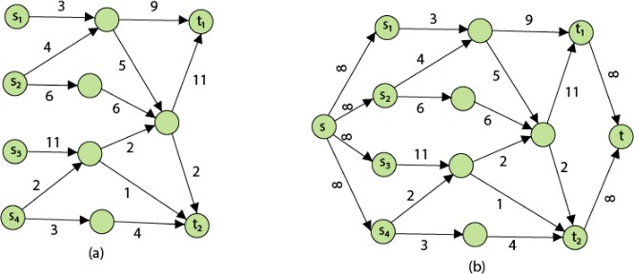

Residual Networks: The Residual Network consists of an edge that can admit more net flow. Suppose we have a flow network G = (V, E) with source s and sink
t. Let f be a flow in G, and examine a pair of vertices u, v ∈ V. The sum of additional net flow we can push from u to v before exceeding the capacity c (u, v) is the residual capacity of (u, v) given by

Network Flow Problems
When the net flow f (u, v) is negative, the residual capacity cf (u,v) is greater than the capacity c (u, v)
Given a flow network G = (V, E) and a flow f, the residual network of G induced by
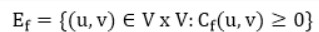
f is Gf = (V, Ef), where

That is, each edge of the residual network, or residual edge, can admit a strictly positive net flow.

Augmenting Path: Given a flow network G = (V, E) and a flow f, an augmenting path p is a simple path from s to t in the residual network Gf. By the solution of the residual network, each edge (u, v) on an augmenting path admits some additional positive net flow from u to v without violating the capacity constraint on the edge.
Let G = (V, E) be a flow network with flow f. The residual capacity of an augmenting path p is

The residual capacity is the maximal amount of flow that can be pushed through the augmenting path. If there is an augmenting path, then each edge on it has a positive capacity. We will use this fact to compute a maximum flow in a flow network.

